**Lab: SVM**

1) Retrieve the excel sheet for the “Sonar data” from the samples on left side pane as mentioned below

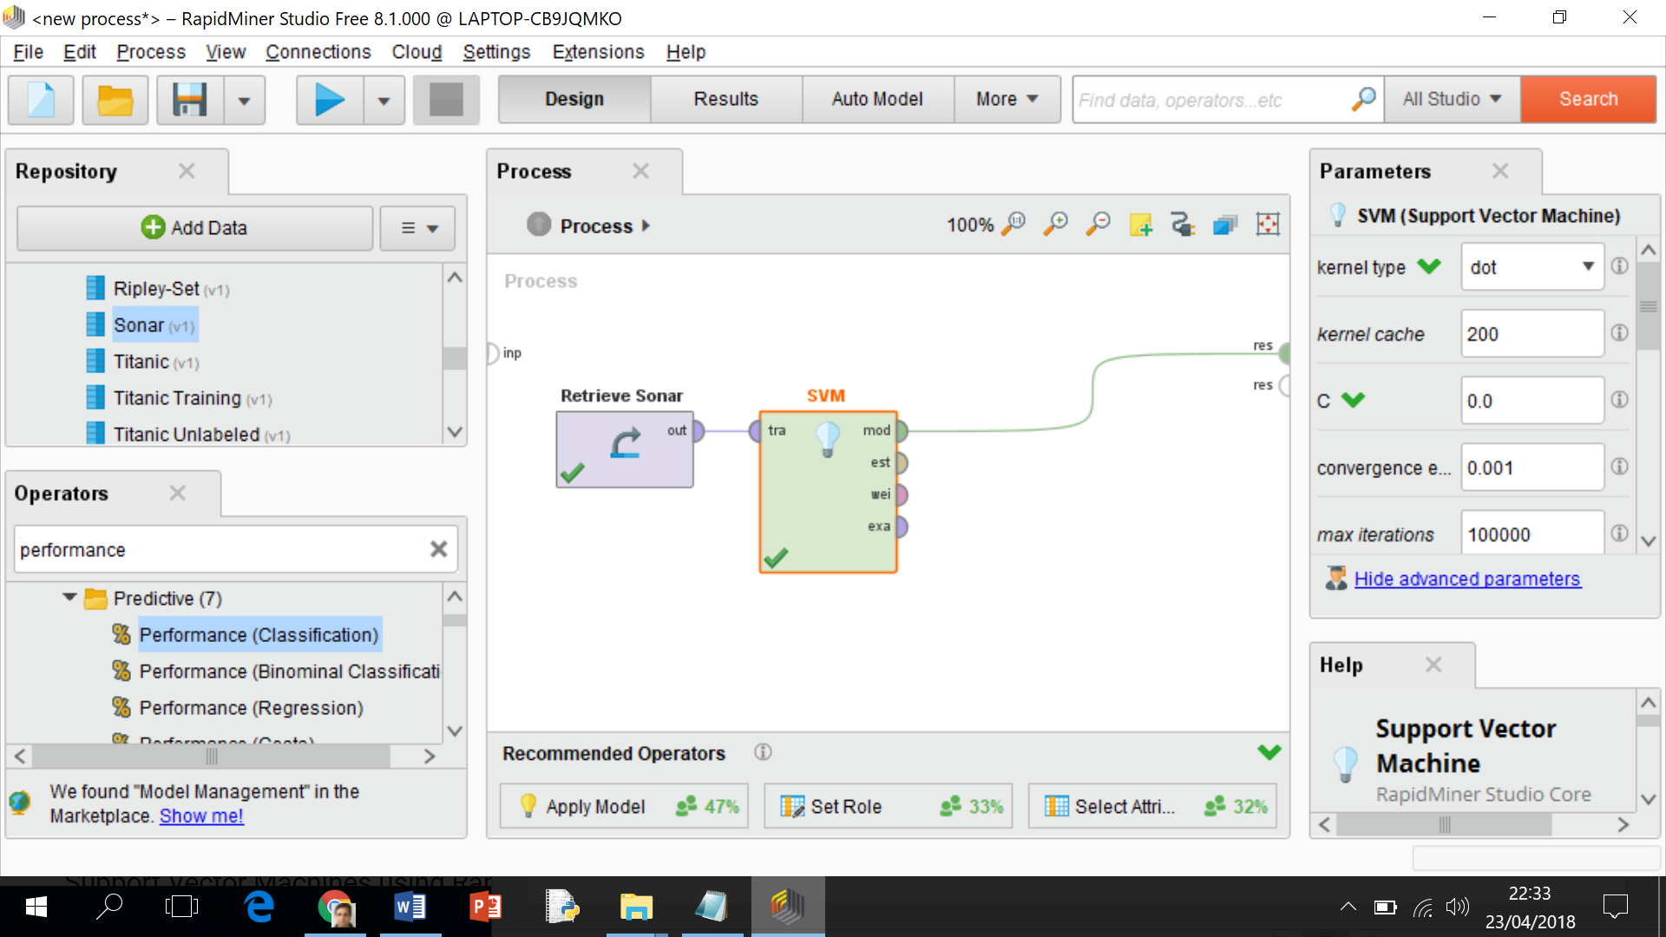

2) First, we understand the process of support vector machine. Sonar data is used for SVM consisting of 16 attributes and one nominal label with two classes.

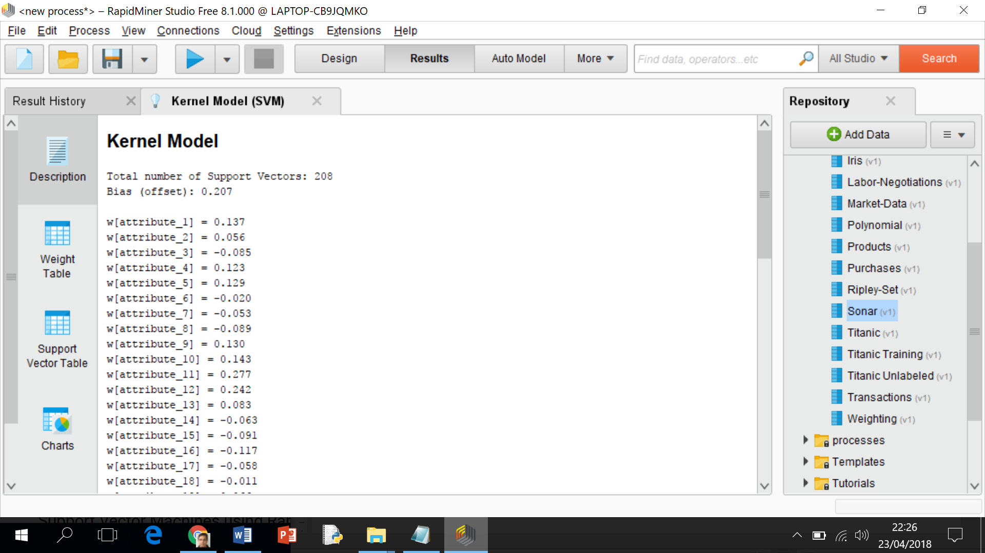

Simple support vector is the linear model. Function is the linear combination of all input variables and the resulting function is always attribute times the weight of the attribute. If the result is above the value, it is called as first-class classifier and below called as the second class classifiers.

3) Drag the cross validation operator into the process window and double click on that, a new window with two sections (Training & Testing) will be opened.

4) Drag the “Support vector machine” operator into the training section and link the appropriate ports. For example, “tra with tra” and “wei with thr”.

5) Drag the “Apply Model” operator into testing section of Process window as mentioned below

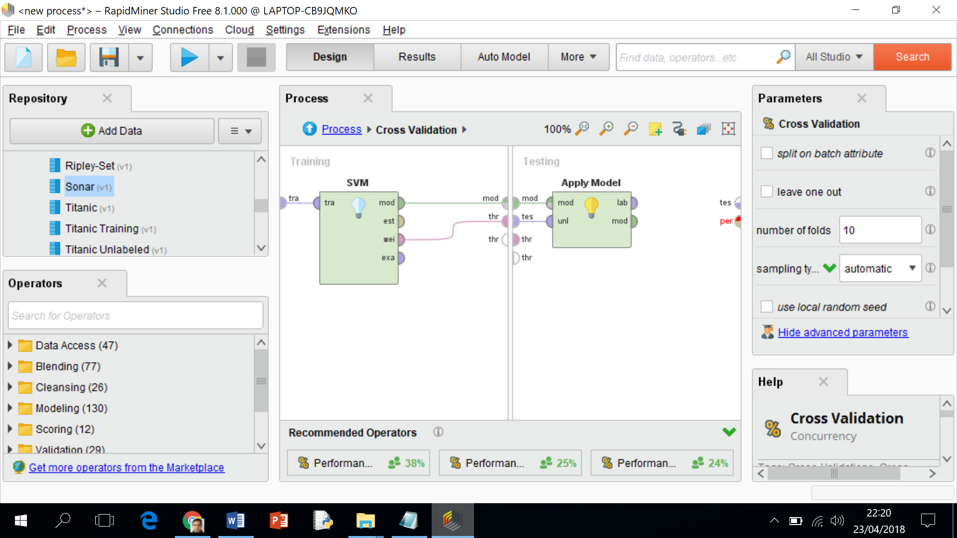

6) Drag another operator “Performance” into testing section of the Process window and link the appropriate ports as shown below

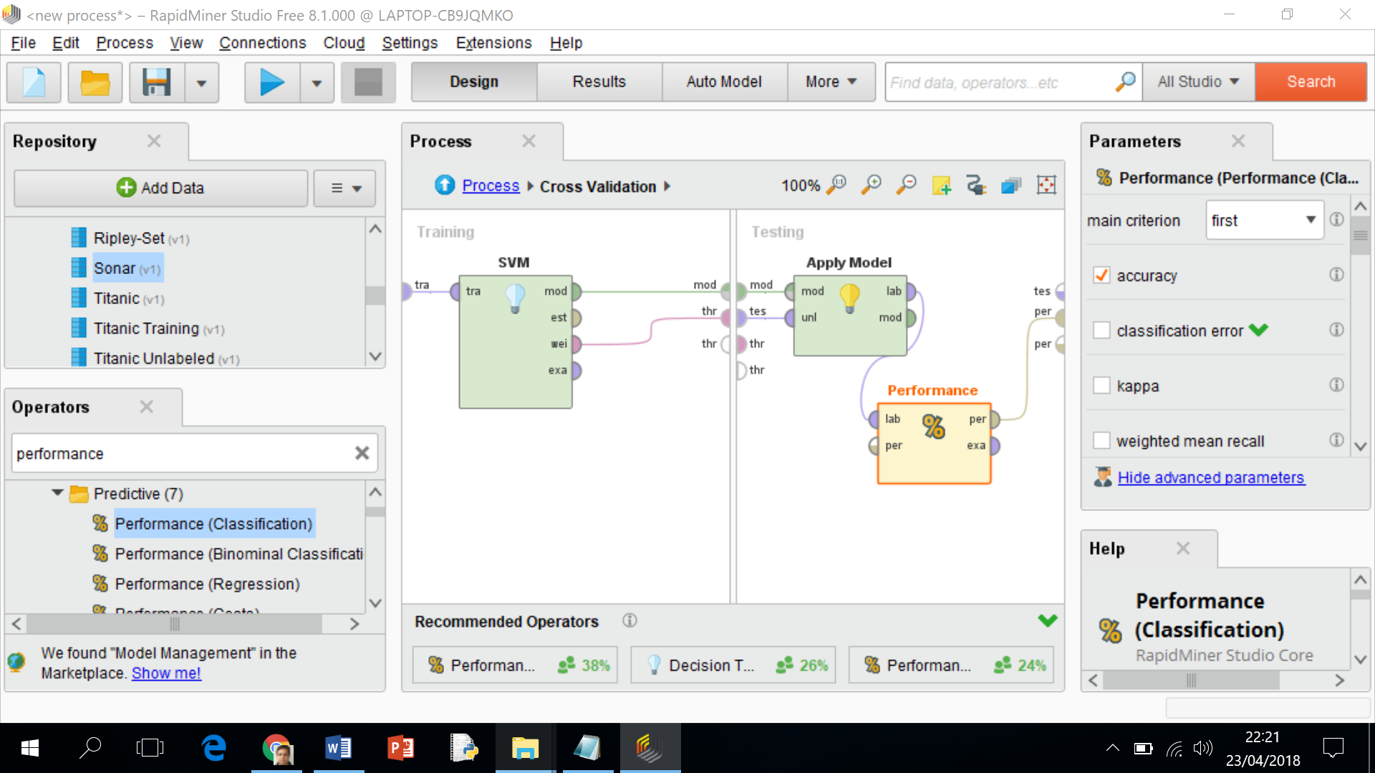

7) Return to the main process and join the “Cross Validations” operator ports to the output as mentioned below

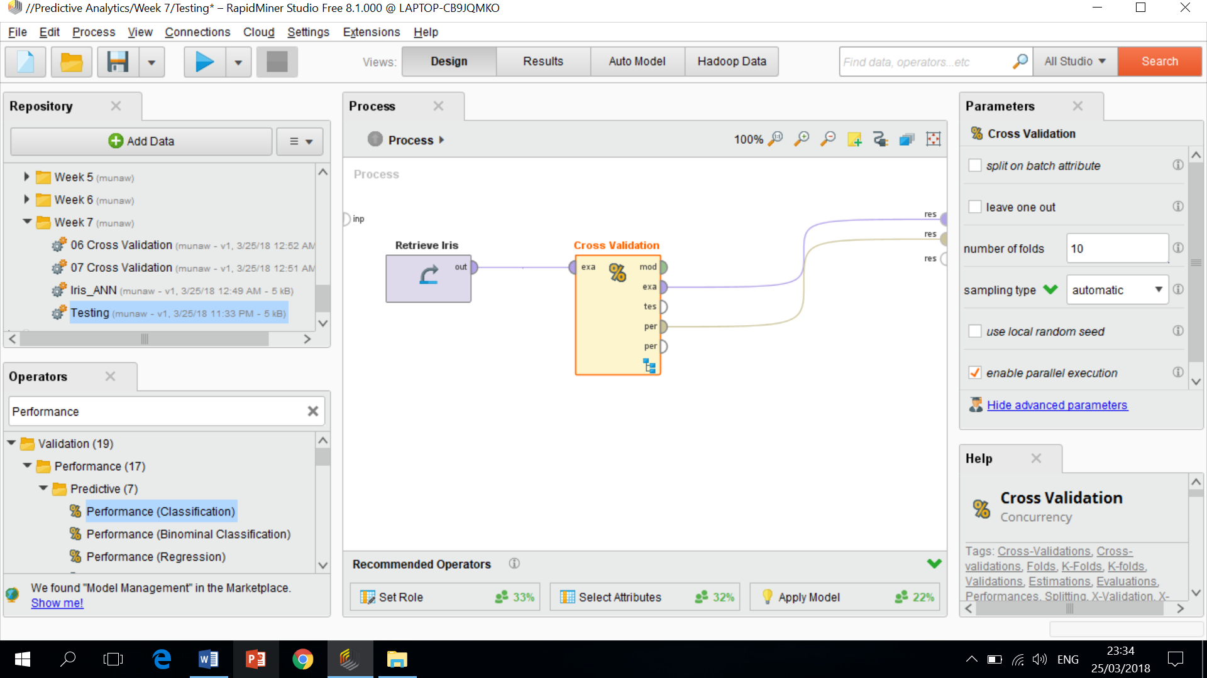

8) Run the process and the confusion matric will be as mentioned below

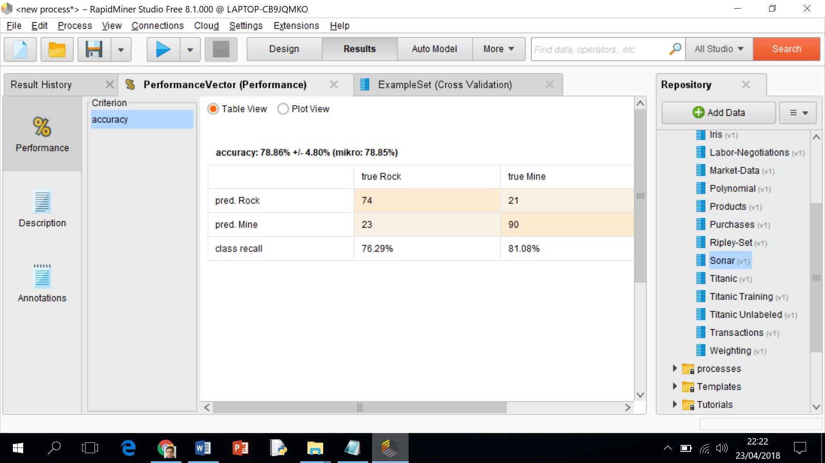

9) If you would like to explore further for the linear or non-linear classifiers as mentioned below

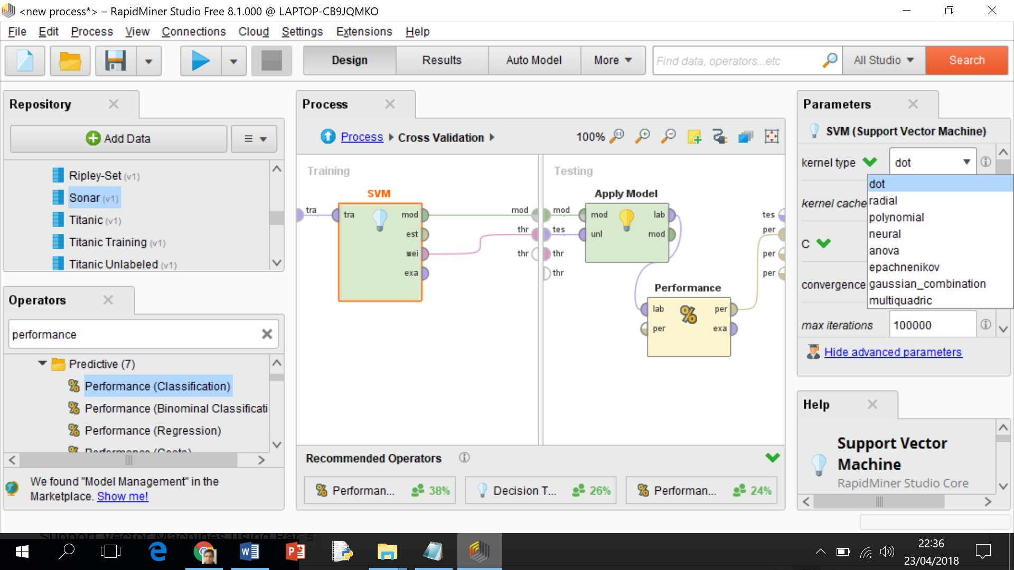

10) The “radial function” is for the non-linear functions, a combination of non-linear Gaussian function or you can explore other variations of the functions. The standard option is linear and other options are non-linear.

11) C describes that SVM focus of generalized or highly focussed model. Higher C value has more impact on the training samples of the data set and this develops a highly specialized SVM model. Lower C value has more general and robust model.

12) Try these non-linear functions and note the change in the accuracy of the performance vector.

13) If you would like to explore further, please you can explore the following youtube video as mentioned below

<https://www.youtube.com/watch?v=27RQRUR7Ubc&t=177s>